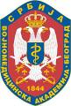

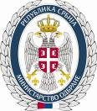
Course „Integrative Medicine-Basic Principles“
March 25, 2013
Teaching Scientific Council Room
Military Medical Academy

Application Form

Participant Data

First and last name |  |  | License no.
Institution
Address of the Institution
Contact phone |  | e-mail

Application form should be sent at: tcsnsl@vma.mod.gov.rs

