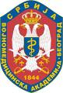

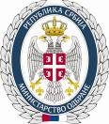
Course „Anti-Inflammatory Asthma Therapies and COPD“
May 16th, 2014
Amphitheater, Military Medical Academy

Registration form

Member data

Last and First Name |  |  | Licence number
Facility
Facility Address
Contact |  | e-mail address

Registration form should be sent by email to: milica.petric@takeda.com

